EXP NO: 2

NAME: Pooja V
Reg No: 192512463

CODE:
clc; clear; close all;

%% ============================================================
% CHARACTERISTICS STUDY OF SIDEBAND POWER AND FREQUENCIES IN AM
% USING MATLAB
% ============================================================

%% 1. INITIAL PARAMETERS

Fs = 1e6; % Sampling frequency = 1 MHz
T = 0.01; % Simulation time = 10 ms

t = 0:1/Fs:T-1/Fs;

% Carrier and message parameters fc = 100e3; % Carrier frequency = 100 kHz fm = 10e3; % Message frequency = 10 kHz

Ac = 1; % Carrier amplitude
Am = 1; % Message amplitude

R = 50; % Load resistance = 50 ohms

%% 2. MODULATION INDEX

mu = Am/Ac;

fprintf('\n');
fprintf('====================================================\n'); fprintf(' AM SIDEBAND POWER AND FREQUENCY STUDY\n'); fprintf('====================================================\n');

fprintf('\nBasic Parameters:\n'); fprintf('Carrier Frequency = %.2f kHz\n',fc/1000); fprintf('Message Frequency = %.2f kHz\n',fm/1000); fprintf('Carrier Amplitude = %.2f V\n',Ac); fprintf('Message Amplitude = %.2f V\n',Am); fprintf('Load Resistance = %.2f Ohm\n',R); fprintf('Modulation Index = %.2f\n',mu);

%% 3. MESSAGE SIGNAL

message = Am*cos(2*pi*fm*t);

%% 4. CARRIER SIGNAL

carrier = Ac*cos(2*pi*fc*t);

%% 5. AM SIGNAL
AM_signal = Ac*(1 + mu*cos(2*pi*fm*t)) ...
.* cos(2*pi*fc*t);

%% ============================================================
% 6. TIME DOMAIN PLOTS
% ============================================================

% Message signal

figure;

plot(t*1000,message,'LineWidth',1.2);

xlabel('Time (ms)'); ylabel('Amplitude (V)');

title('Message Signal');

grid on;

xlim([0 1]);

% Carrier signal

figure;

plot(t*1000,carrier,'LineWidth',1);

xlabel('Time (ms)');
ylabel('Amplitude (V)');

title('Carrier Signal');

grid on;

xlim([0 0.2]);

% AM signal

figure;

plot(t*1000,AM_signal,'LineWidth',1);

xlabel('Time (ms)'); ylabel('Amplitude (V)');

title('Amplitude Modulated (AM) Signal');

grid on;

xlim([0 1]);

%% ============================================================
% 7. AM SPECTRUM
% ============================================================

N = length(AM_signal);
AM_fft = fft(AM_signal);

AM_fft_shifted = fftshift(AM_fft);

f = (-N/2:N/2-1)*(Fs/N);

AM_magnitude = abs(AM_fft_shifted)/N;

figure;

plot(f/1000,AM_magnitude,'LineWidth',1.2);

xlabel('Frequency (kHz)'); ylabel('Magnitude');

title('AM Frequency Spectrum');

grid on;

xlim([70 130]);

%% ============================================================
% 8. FIND USB AND LSB FREQUENCIES
% ============================================================

f_USB = fc + fm;

f_LSB = fc - fm;
fprintf('\n'); fprintf('Sideband Frequencies:\n');

fprintf('LSB Frequency = %.2f kHz\n',f_LSB/1000);

fprintf('Carrier Frequency = %.2f kHz\n',fc/1000);

fprintf('USB Frequency = %.2f kHz\n',f_USB/1000);

%% ============================================================
% 9. BANDWIDTH
% ============================================================

BW_AM = 2*fm;

fprintf('\n'); fprintf('AM Bandwidth:\n');

fprintf('BW = 2fm = %.2f kHz\n',BW_AM/1000);

%% ============================================================
% 10. CARRIER POWER
% ============================================================

Pc = Ac^2/(2*R);

fprintf('\n'); fprintf('Carrier Power:\n'); fprintf('Pc = %.6f W\n',Pc);

%% ============================================================
% 11. SIDEband POWER
% ============================================================

P_USB = (mu^2 * Pc)/4;

P_LSB = (mu^2 * Pc)/4;

P_SB_total = P_USB + P_LSB;

%% ============================================================
% 12. TOTAL AM POWER
% ============================================================

P_total = Pc + P_SB_total;

%% ============================================================
% 13. POWER EFFICIENCY
% ============================================================

efficiency = (P_SB_total/P_total)*100;

%% ============================================================
% 14. DISPLAY POWER RESULTS
% ============================================================

fprintf('\n');
fprintf('Power Calculations:\n');

fprintf('Carrier Power = %.6f W\n',Pc);

fprintf('USB Power = %.6f W\n',P_USB);

fprintf('LSB Power = %.6f W\n',P_LSB);

fprintf('Total Sideband Power = %.6f W\n',P_SB_total);

fprintf('Total AM Power = %.6f W\n',P_total);

fprintf('Transmission Efficiency = %.2f %%\n',efficiency);

%% ============================================================
% 15. MODULATION INDEX STUDY
% ============================================================

mu_values = 0.1:0.1:1.0;

P_USB_values = zeros(size(mu_values));

P_LSB_values = zeros(size(mu_values));

P_SB_values = zeros(size(mu_values));

P_total_values = zeros(size(mu_values));

Efficiency_values = zeros(size(mu_values));

for k = 1:length(mu_values)

m_index = mu_values(k);

P_USB_values(k) = ...
(m_index^2 * Pc)/4;

P_LSB_values(k) = ...
(m_index^2 * Pc)/4;

P_SB_values(k) = ...
P_USB_values(k) + P_LSB_values(k);

P_total_values(k) = ...
Pc + P_SB_values(k);

Efficiency_values(k) = ...
(P_SB_values(k)/P_total_values(k))*100;

end

%% ============================================================
% 16. DISPLAY MODULATION INDEX TABLE
% ============================================================

fprintf('\n');
fprintf('====================================================\n'); fprintf(' POWER VS MODULATION INDEX\n'); fprintf('====================================================\n');

fprintf('\n');

fprintf(' Mu USB Power LSB Power Total SB Total AM\n');

fprintf('----------------------------------------------------\n');

for k = 1:length(mu_values)

fprintf(' %.1f %.6f %.6f %.6f %.6f\n', ... mu_values(k), ...
P_USB_values(k), ...
P_LSB_values(k), ...
P_SB_values(k), ...
P_total_values(k));

end

fprintf('----------------------------------------------------\n');

%% ============================================================
% 17. USB POWER VS MODULATION INDEX
% ============================================================

figure;

plot(mu_values,P_USB_values,'o-','LineWidth',1.5);
xlabel('Modulation Index (\mu)'); ylabel('USB Power (W)');

title('USB Power vs Modulation Index');

grid on;

%% ============================================================
% 18. LSB POWER VS MODULATION INDEX
% ============================================================

figure;

plot(mu_values,P_LSB_values,'s-','LineWidth',1.5);

xlabel('Modulation Index (\mu)'); ylabel('LSB Power (W)');

title('LSB Power vs Modulation Index');

grid on;

%% ============================================================
% 19. TOTAL SIDEBAND POWER VS MODULATION INDEX
% ============================================================

figure;

plot(mu_values,P_SB_values,'^-','LineWidth',1.5);
xlabel('Modulation Index (\mu)'); ylabel('Total Sideband Power (W)');

title('Total Sideband Power vs Modulation Index');

grid on;

%% ============================================================
% 20. TOTAL AM POWER VS MODULATION INDEX
% ============================================================

figure;

plot(mu_values,P_total_values,'o-','LineWidth',1.5);

xlabel('Modulation Index (\mu)'); ylabel('Total AM Power (W)');

title('Total AM Power vs Modulation Index');

grid on;

%% ============================================================
% 21. TRANSMISSION EFFICIENCY
% ============================================================

figure;
plot(mu_values,Efficiency_values,'d-','LineWidth',1.5);

xlabel('Modulation Index (\mu)'); ylabel('Efficiency (%)');

title('AM Transmission Efficiency vs Modulation Index');

grid on;

%% ============================================================
% 22. COMPARE USB AND LSB POWER
% ============================================================

figure;

plot(mu_values,P_USB_values,'o-','LineWidth',1.5);

hold on;

plot(mu_values,P_LSB_values,'s-','LineWidth',1.5);

xlabel('Modulation Index (\mu)'); ylabel('Power (W)');

title('USB and LSB Power Comparison');

legend('USB Power','LSB Power');

grid on;
%% ============================================================
% 23. AM SPECTRUM FOR DIFFERENT MODULATION INDICES
% ============================================================

mu_plot = [0.25 0.5 0.75 1.0];

figure;

for k = 1:length(mu_plot)

mu_temp = mu_plot(k);

AM_temp = Ac*(1 + ... mu_temp*cos(2*pi*fm*t)) ...
.* cos(2*pi*fc*t);

spectrum_temp = fftshift(fft(AM_temp));

magnitude_temp = ...
abs(spectrum_temp)/N;

subplot(4,1,k);

plot(f/1000,magnitude_temp);

xlabel('Frequency (kHz)'); ylabel('Magnitude'); title(['AM Spectrum, \mu = ', ...
num2str(mu_temp)]);

grid on;

xlim([70 130]);

end

%% ============================================================
% 24. ENVELOPE OF AM SIGNAL
% ============================================================

envelope_upper = Ac*(1 + mu*cos(2*pi*fm*t));

envelope_lower = -Ac*(1 + mu*cos(2*pi*fm*t));

figure;

plot(t*1000,AM_signal);

hold on;

plot(t*1000,envelope_upper,'--','LineWidth',1.2);

plot(t*1000,envelope_lower,'--','LineWidth',1.2);

xlabel('Time (ms)'); ylabel('Amplitude (V)'); title('AM Signal and Its Envelope');

legend('AM Signal','Upper Envelope','Lower Envelope');

grid on;

xlim([0 1]);

%% ============================================================
% 25. IMPORTANT RESULTS AT 100% MODULATION
% ============================================================

mu_100 = 1;

P_USB_100 = (mu_100^2 * Pc)/4;

P_LSB_100 = (mu_100^2 * Pc)/4;

P_SB_100 = P_USB_100 + P_LSB_100;

P_total_100 = Pc + P_SB_100;

efficiency_100 = ...
(P_SB_100/P_total_100)*100;

fprintf('\n');
fprintf('====================================================\n'); fprintf(' RESULTS FOR 100%% MODULATION\n'); fprintf('====================================================\n');

fprintf('Carrier Power = %.6f W\n',Pc);

fprintf('USB Power = %.6f W\n',P_USB_100);

fprintf('LSB Power = %.6f W\n',P_LSB_100);

fprintf('Total Sideband Power = %.6f W\n',P_SB_100);

fprintf('Total AM Power = %.6f W\n',P_total_100);

fprintf('Transmission Efficiency = %.2f %%\n',efficiency_100);

fprintf('====================================================\n');

%% ============================================================
% 26. FINAL CONCLUSION
% ============================================================

fprintf('\n');
fprintf('CONCLUSION:\n');

fprintf(['1. USB frequency = fc + fm.\n']);

fprintf(['2. LSB frequency = fc - fm.\n']);

fprintf(['3. AM bandwidth = 2fm.\n']);

fprintf(['4. Sideband power increases with mu^2.\n']);

fprintf(['5. At 100%% modulation, total sideband power = Pc/2.\n']);

fprintf(['6. At 100%% modulation, total AM power = 1.5Pc.\n']);

fprintf(['7. Maximum theoretical AM efficiency = 33.33%%.\n']);

fprintf('\n====================================================\n'); fprintf(' SIMULATION COMPLETED\n'); fprintf('====================================================\n');

OUTPUT
Figure1:
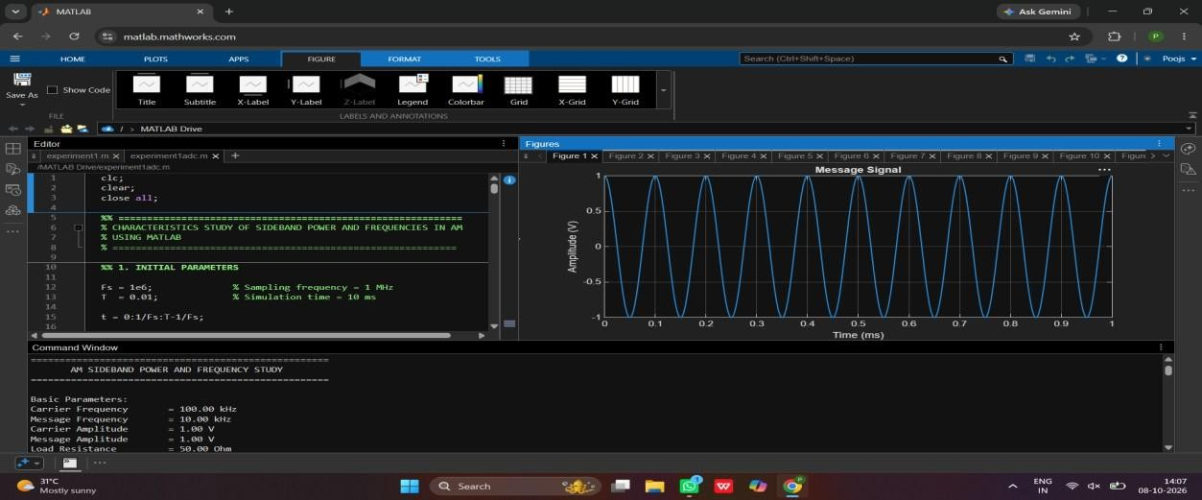
Figure 2:
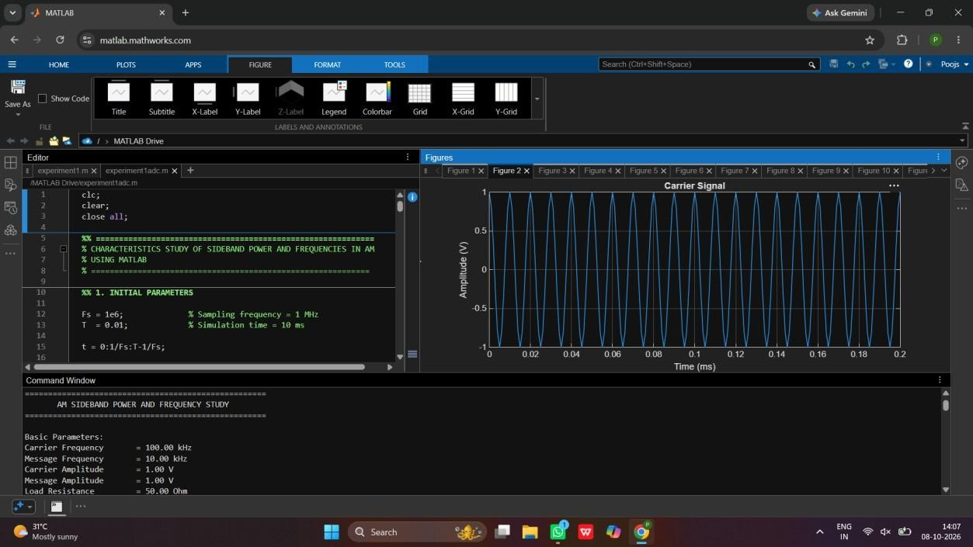

Figure 3:
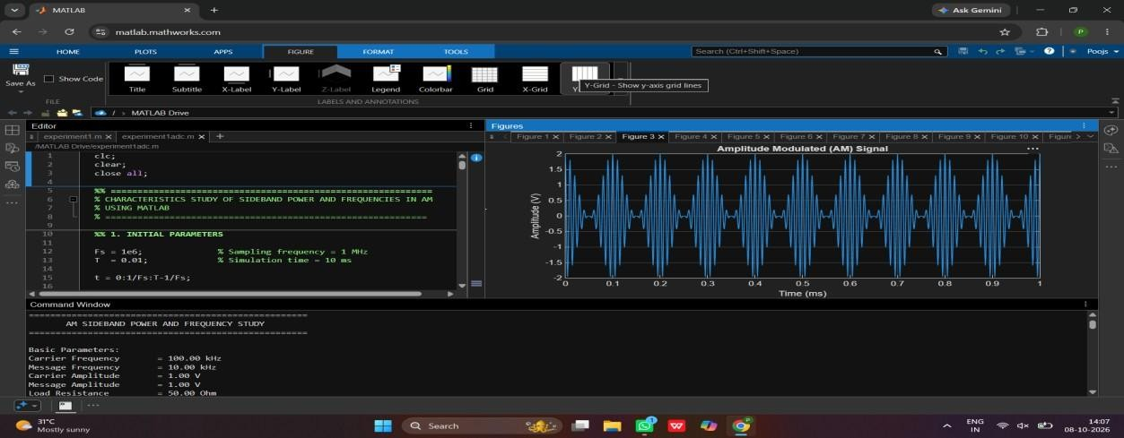
Figure 4:
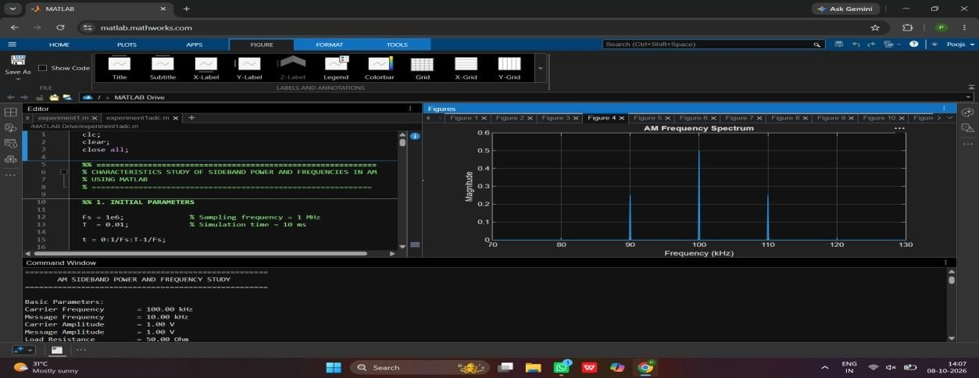
Figure 5:
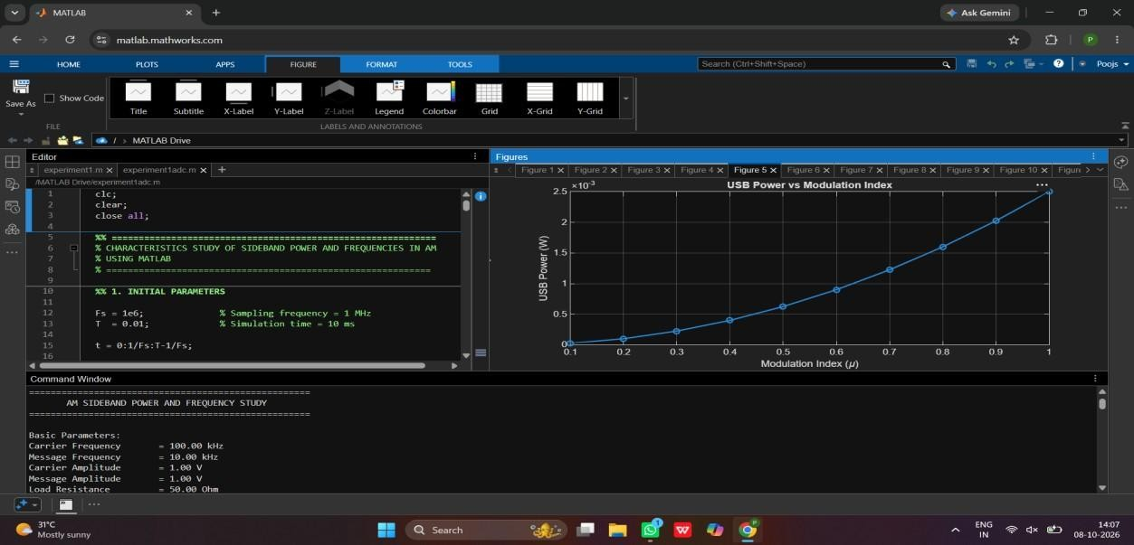

Figure 6:
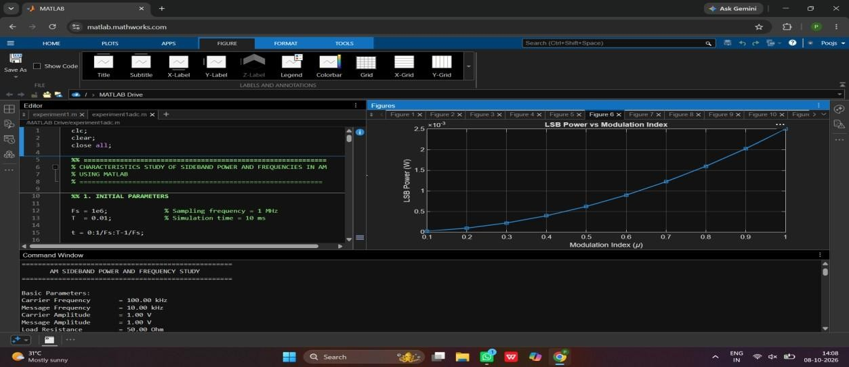
Figure 7:
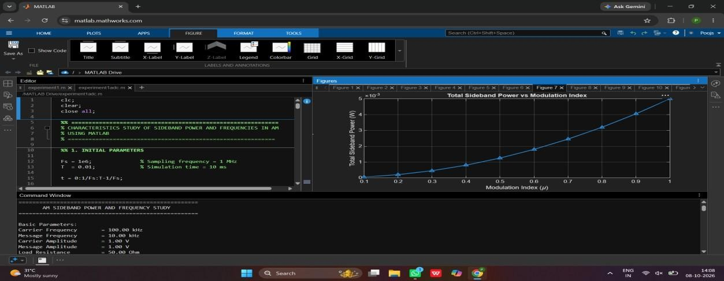
Figure 8:
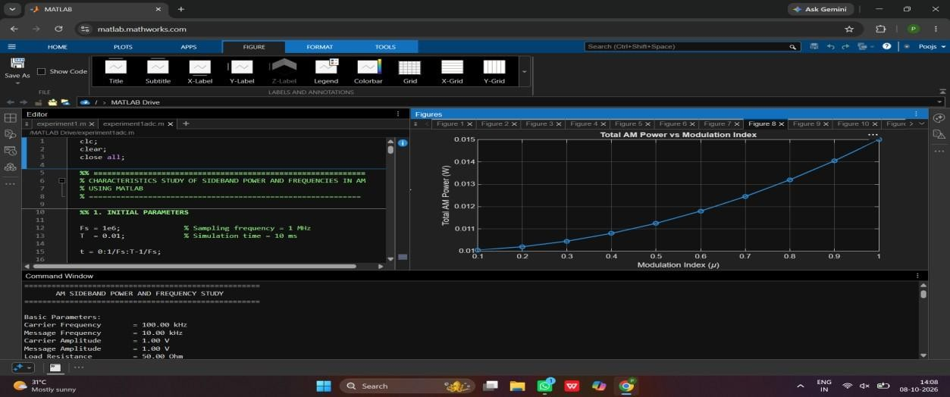

Figure 9:
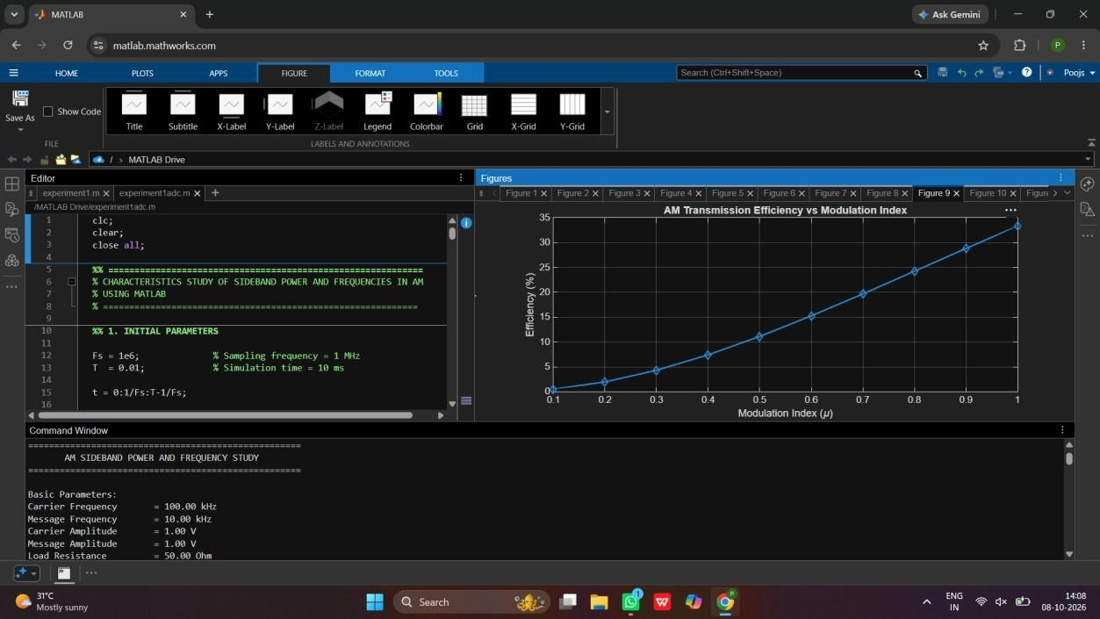
Figure 10:
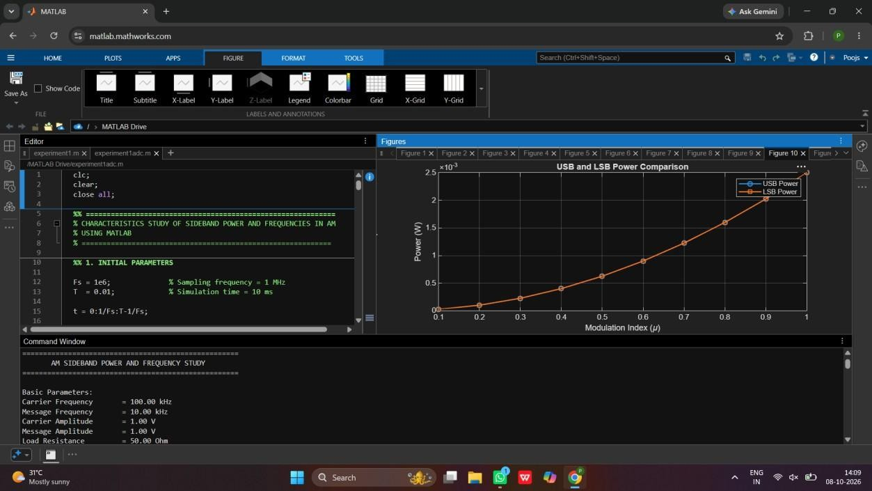

Figure 11:
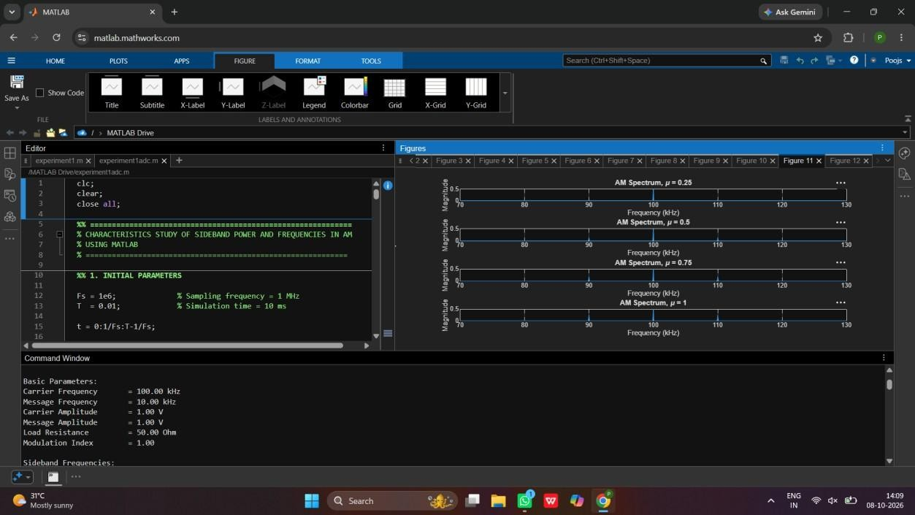
Figure 12:
